Mat Hanson

11575596 | mathanson87@gmail.com

Assessment 2 – DNS Practical

ITC514 – Linux Server Administration

# Part One

## Installation of BIND

My first task is to install BIND so that I can configure my DNS server. I used the yum utility to search for and download the latest bind package (CentOS.org, 2005).

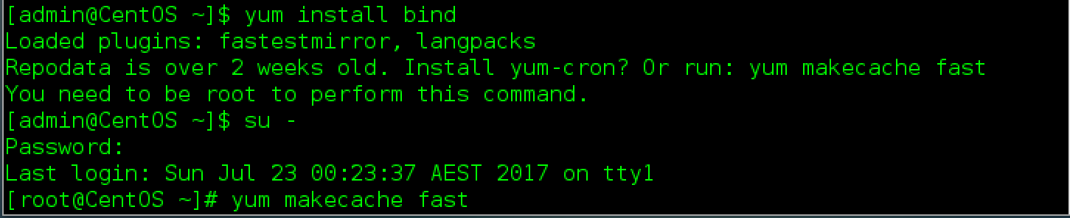

I received an error stating that the repodata is over 2 weeks old and advising me to run “yum makecache fast” command.

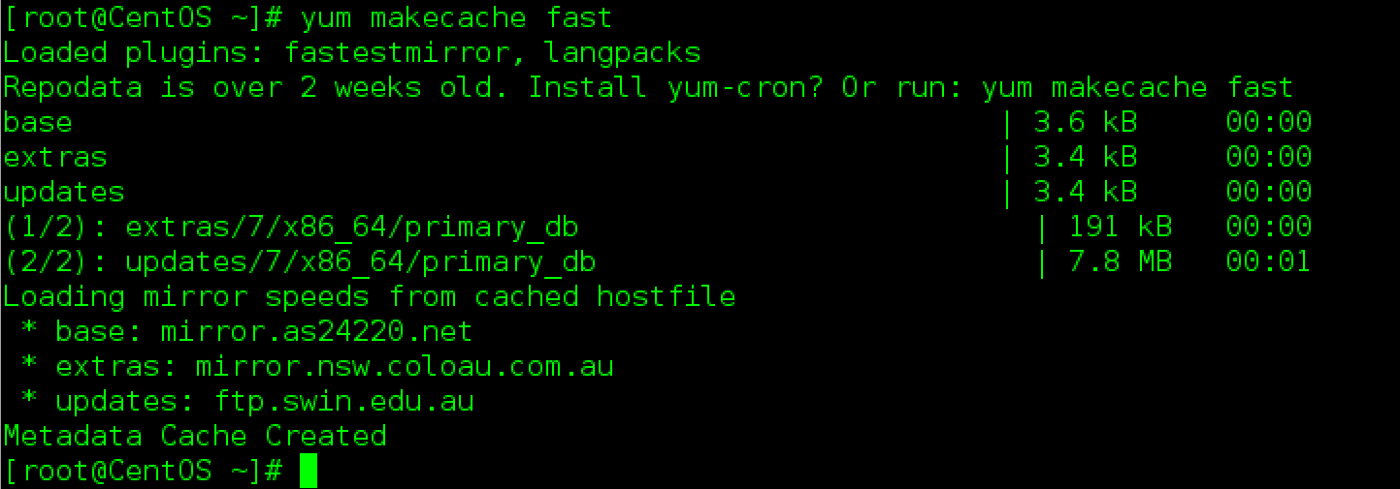

I ran “yum makecache fast” which then allowed me to run “yum install bind” without error.

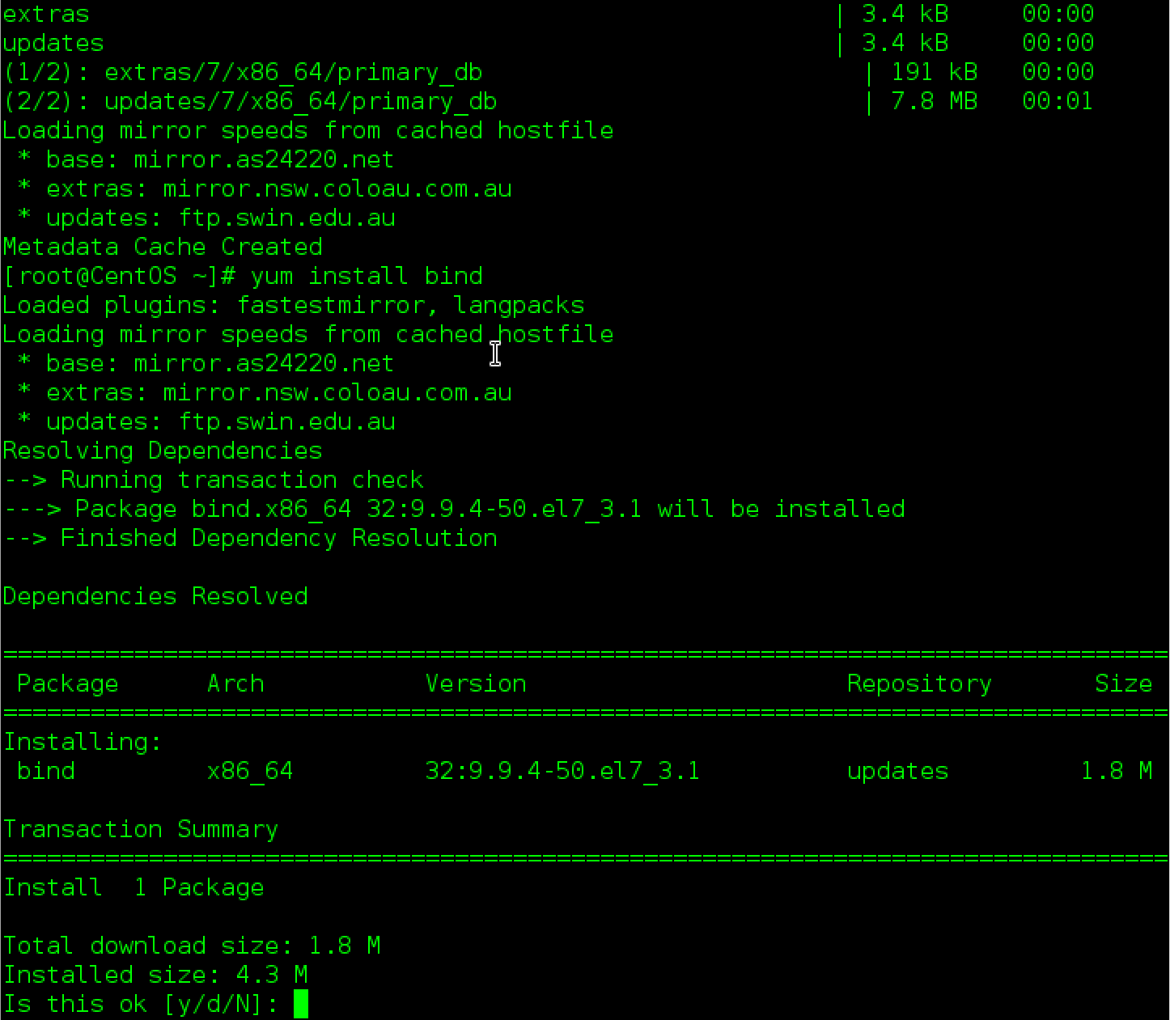

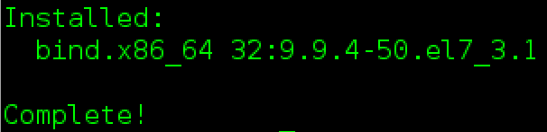

BIND has now successfully been installed.

## Network Configuration

There are a few network configuration changes that I have decided would be best for my DNS server. Firstly, I am going to change the hostname of my server to “DNS”. Using the “hostname” command, I changed the hostname to “DNS”.

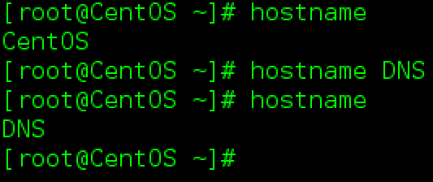

I soon realised that the hostname command did not change the hostname permanently. I found that I would need to use the nmtui utility to statically assign the hostname (Raj, 2017).

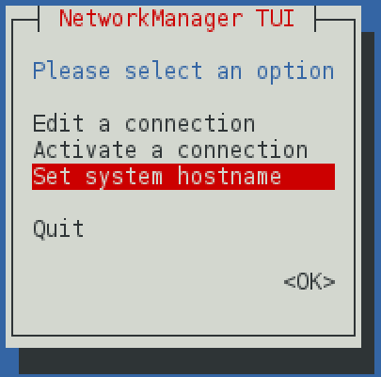

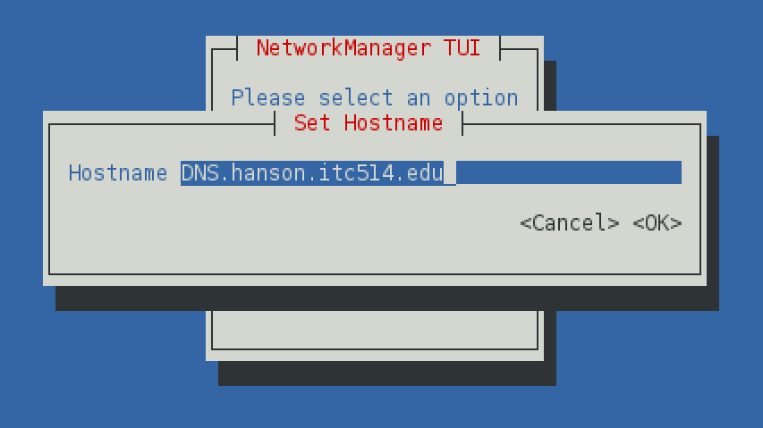

I performed a reboot to make sure that the configuration changes were permanent, which they were.

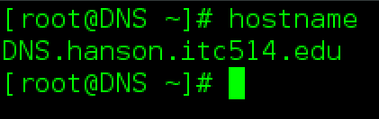

I then used Vi to edit the “/etc/hosts” file to add the new hostname and IP address.



I checked the resolv.conf file and noticed that this file is being updated by NetworkManager. After researching the issue, it seems that the PeerDNS attribute in the “/etc/sysconfig/network-scripts/ifcfg-enp0s3” file causes this behaviour (Geniar, 2015).

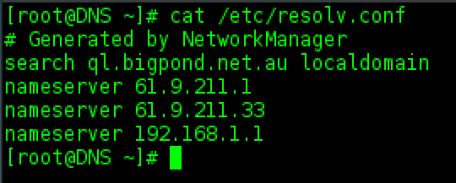

The server is currently set to DHCP (as per screenshot below). I will be editing this file to change from DHCP to static IP and to remove PEERDNS attribute in order to stop NetworkManager from automatically updating resolv.conf. Static IP is required so that we are always dealing with the same IP address, this could also be achieved with a reserved IP address in DHCP but static IP is an easier option for this configuration without any negative effects.

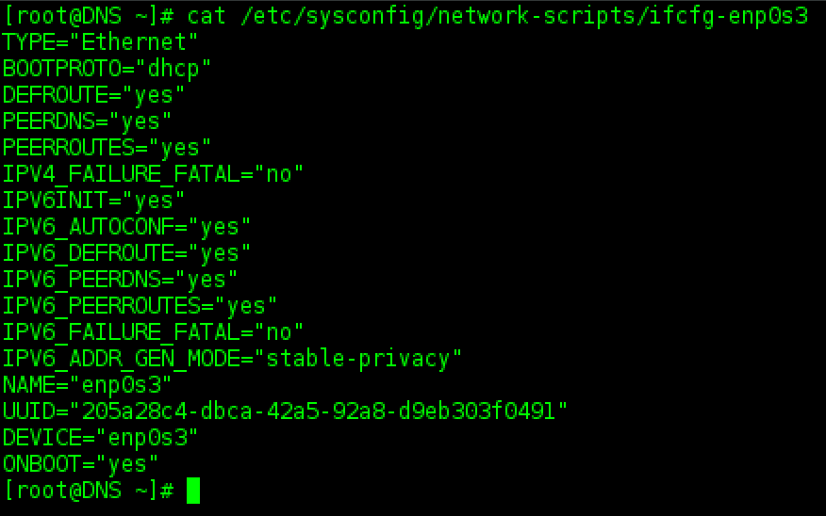

Created a back up of the interface configuration file before making any changes.



Checked to make sure the backup was created and that the permissions were copied also.

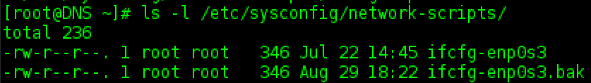

After making a backup, I used Vi to edit “ifcfg-enp0s3”.

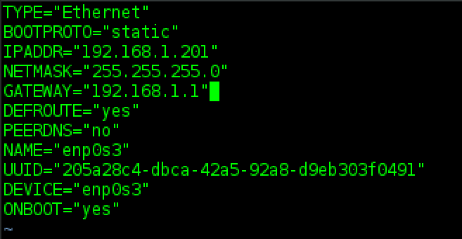

I then edited the resolv.conf file using Vi, adding 192.168.1.201 as the first DNS server, followed by two ISP DNS servers and lastly my gateway.

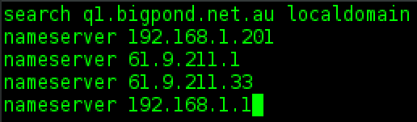

After a reboot, I checked the configuration with “ifconfig” and by pinging [www.google.com](http://www.google.com).

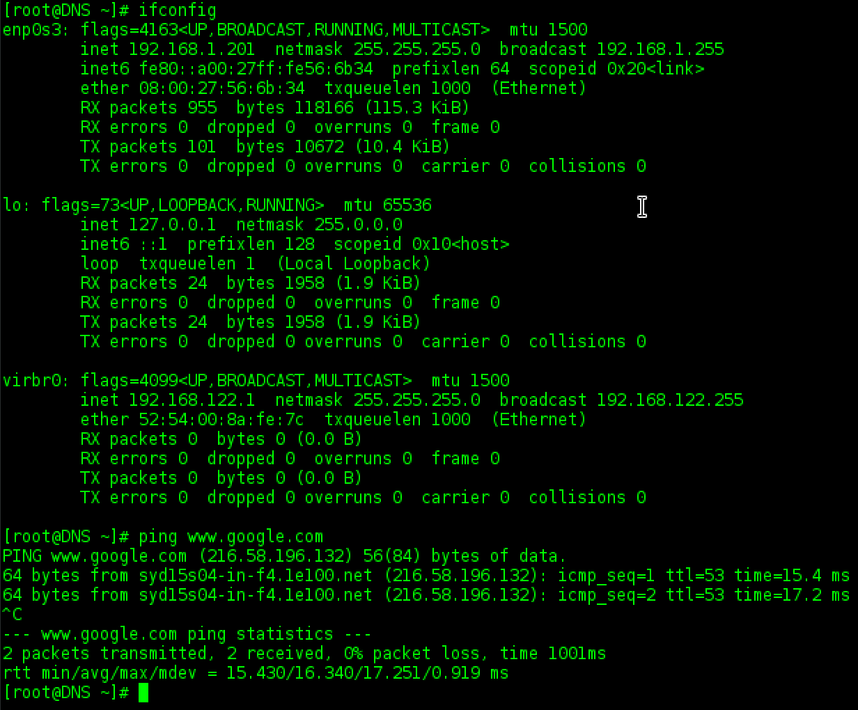

I also tested to make sure that resolv.conf kept its configuration, which it had.

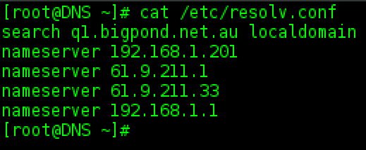

Lastly, I will test pinging the hostname of this server, “DNS”.



## Configuration of BIND

Firstly, I am going to use Vi to open the named.conf file in order to add the forward and reverse lookup zones.



I added the forward lookup zone for ‘hanson.itc514.edu”, defining as the master server and describing where the zone file database will be stored. I then added the reverse lookup zone for “10.168.192.in-addr.arpa”. Page 613. I have also made the following configuration modifications –

* Listen-on-v6 port 53 set to none so that the server does not attempt to serve DNS requests on an IPv6 interface
* Set allow-query to any, so that any hosts can submit DNS requests to the server
* Recursion turned off as I do not want this server attempting to send iterative requests

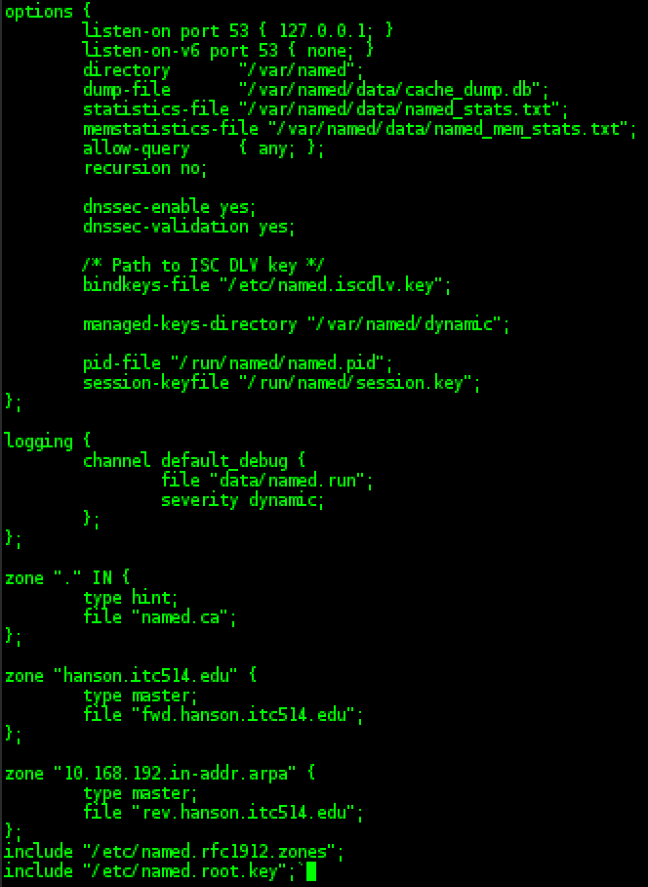

Next, I will need to create the zone files with which I referred to in the named.conf file. I found “named.empty” in the /var/named directory and copied this file to create the forward and reverse lookup zone files.

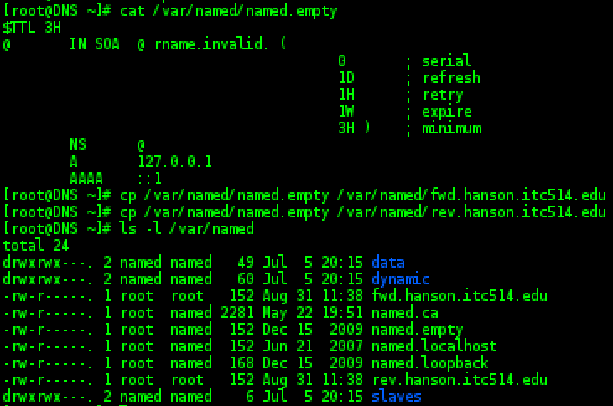

The “named.empty” file seemed to be a good template for my zone files.

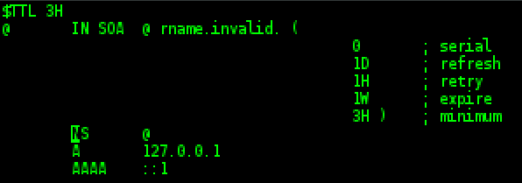

After some modifications to “fwd.hanson.itc514.edu” my zone file looked as follows –

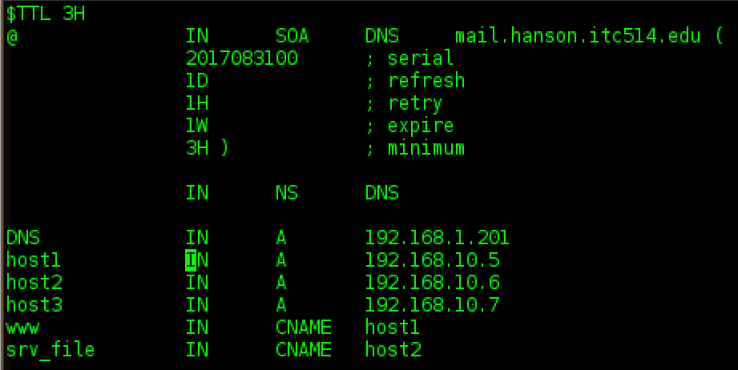

Due to the default behaviour when the “$ORIGIN” directive is not defined, I have used the @ symbol to refer to the domain name referenced in the named.conf file and I decided not to add the period after the nameserver and let the configuration append the domain from the zone in the named.conf file as well. As required, I have added the 3 host PC A records along with the 2 CNAME records.

I then opened “rev.hanson.itc514.edu” with Vi. Again, I used the @ symbol instead of writing out the zone name. Whilst writing this configuration file, I realised that my nameserver IP address should be configured within the 192.168.10.0/24 subnet for this reverse lookup zone to work properly.

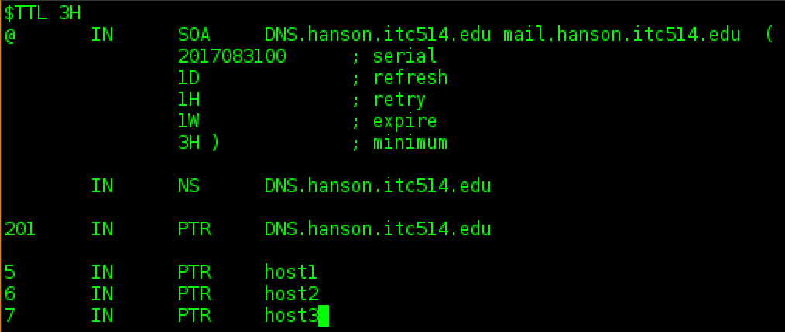

I will need to go back through the configuration and change the IP address from 192.168.1.201 to the new address 192.168.10.100.

Firstly, I made the modification to the /etc/hosts file.



Secondly, I modified the interface file “ifcfg-enp0s3”. I changed the IP address to 192.168.10.100 so that it is in the same subnet as the hosts, I also removed the gateway from this file as I decided that it was not necessary and was not within the subnet anyway.

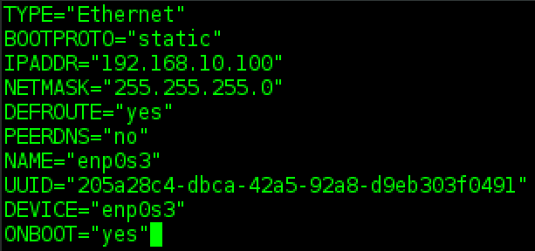

Thirdly, I changed the A record in fwd.hanson.itc514.edu to 192.168.10.100.

Lastly, I will need to modify the “resolv.conf” file to refer to the new IP address. While making this change, I realised that I do not need either of the ISP’s DNS addresses or my gateway address. So I edited the resolv.conf file to only include the DNS server’s IP address and removed the the Bigpond reference in the search directive in lieu of the local domain. I also added the domain directive with the local domain. This way, all DNS requests will stay within this network.

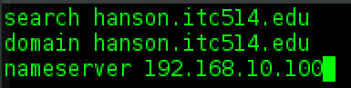

After a reboot, I tested to make sure the configuration was still correct.

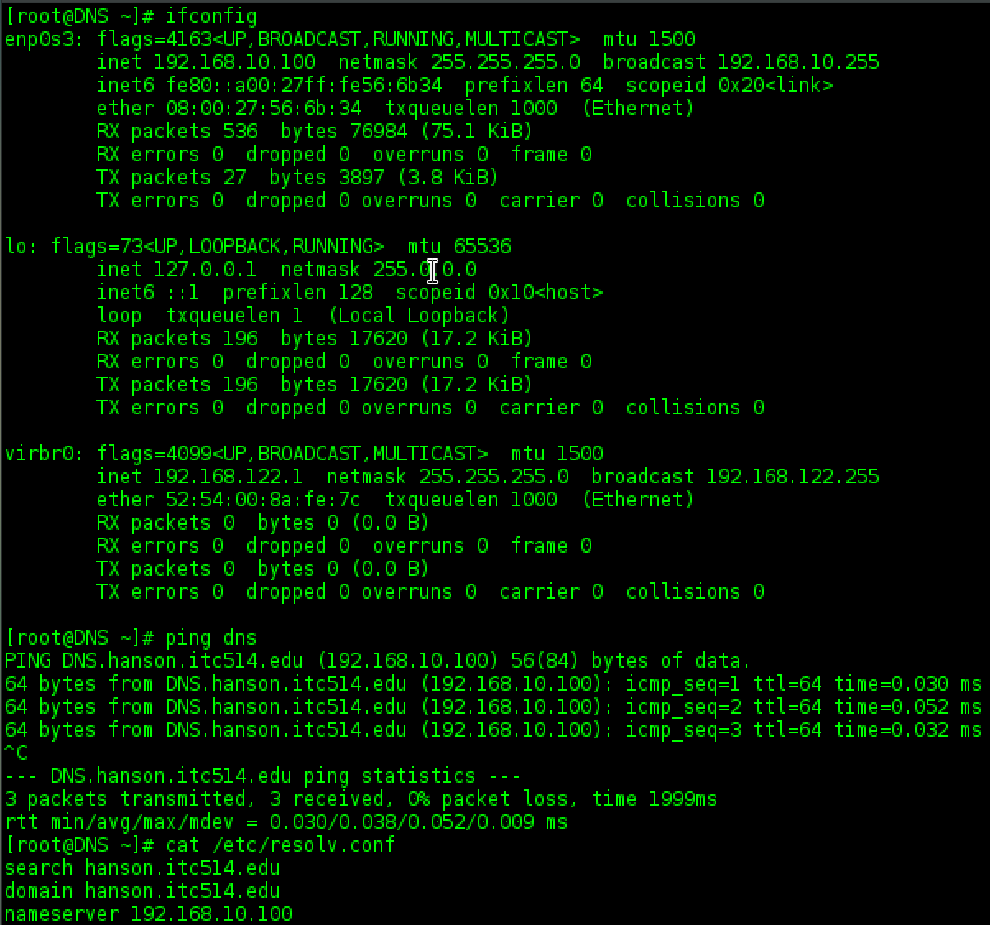

After this networking configuration correction, I used “named-checkconf” to test my named.conf file for errors. I have a few errors which I need to check.

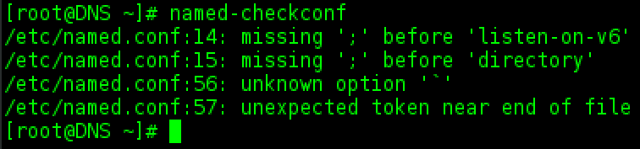

I checked my named.conf file and there were a couple of semi-colons which I forgot to add and also another stray character at the end of the file. After fixing these issues I ran named-checkconf again, with no issues detected.

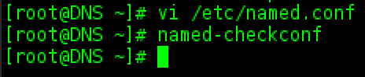

I attempted to start the named service but was unable to start the service due to errors.

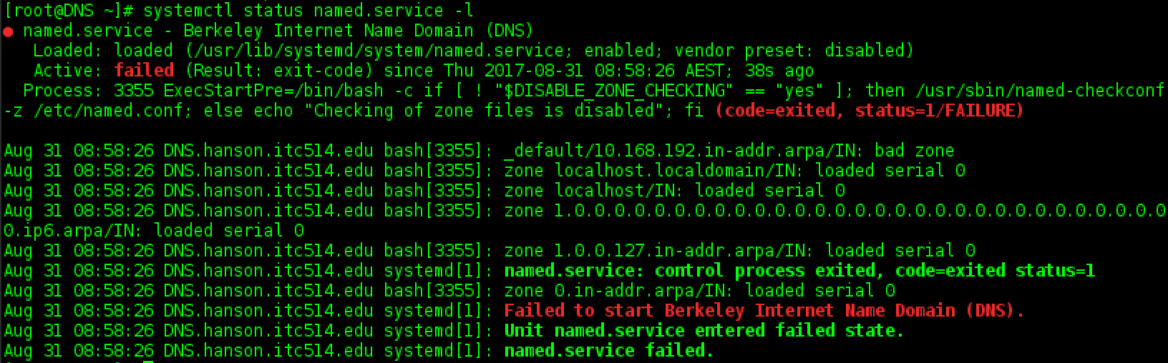

I checked my named.conf again and everything looked fine. I commented out both of my forward and reverse lookup zones and no longer received the error. I then tried starting named with only the reverse lookup zone commented out, and I received a different error – a permissions issue on the zone file. I then tried starting named with only the forward lookup zone commented out and I received the same error as originally, which led me to believe there was an issue with my reverse lookup zone file. I opened the file and checked IPs and hostnames – after a minute I realised that I had not added a period to the hostnames, and within the reverse lookup zone that would mean that it would add “.10.168.192” on the end of the hostnames.

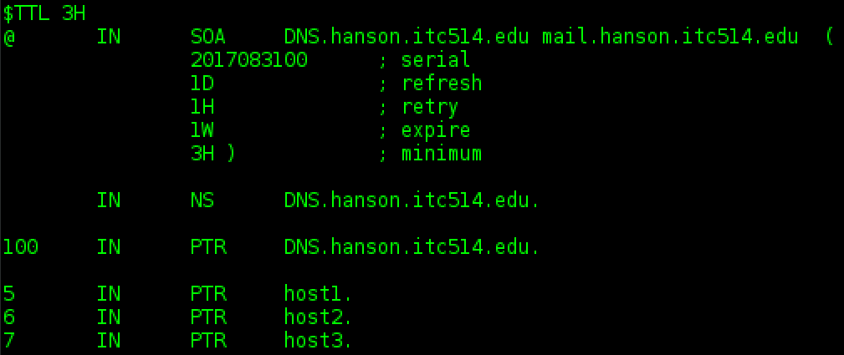

After making the configuration change, I changed the named.conf file back to normal – without the commented zones. I now receive the same permission issue on both zones.

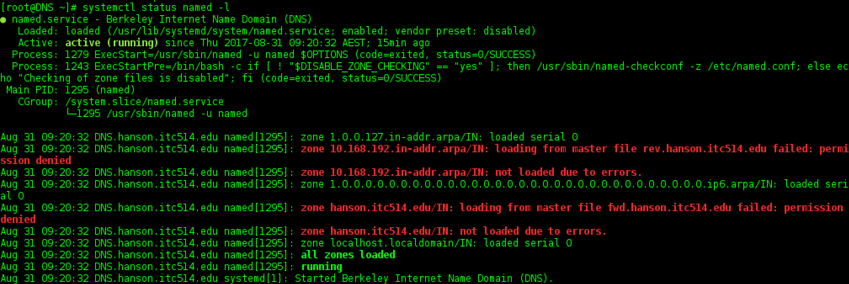

I took another look at the permissions of my zone files and noticed that the ownership of the files was incorrect. Using the “chown” command I modified the ownership to match the other example zone files with named as a group ownership.

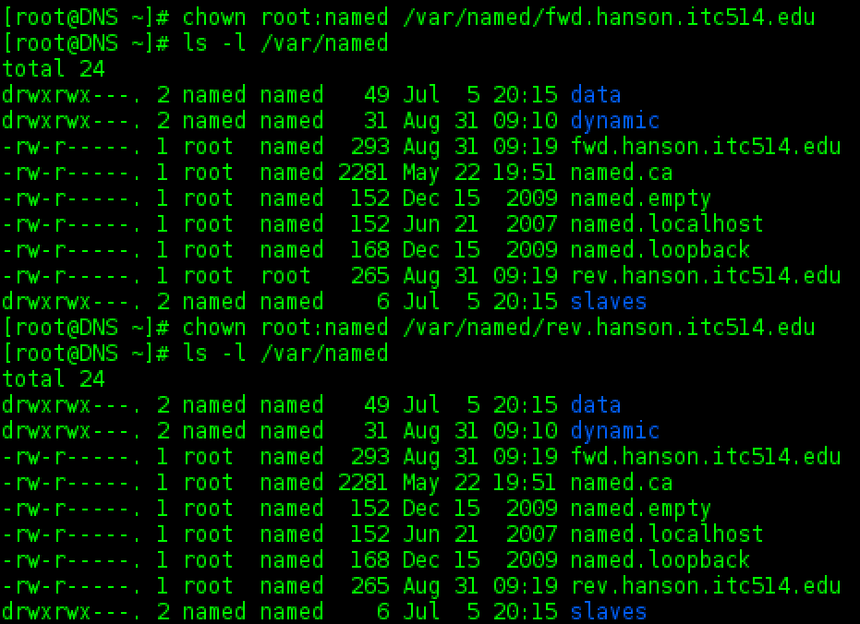

After a reboot, I checked the status of the named service and the zones are now loading fine.

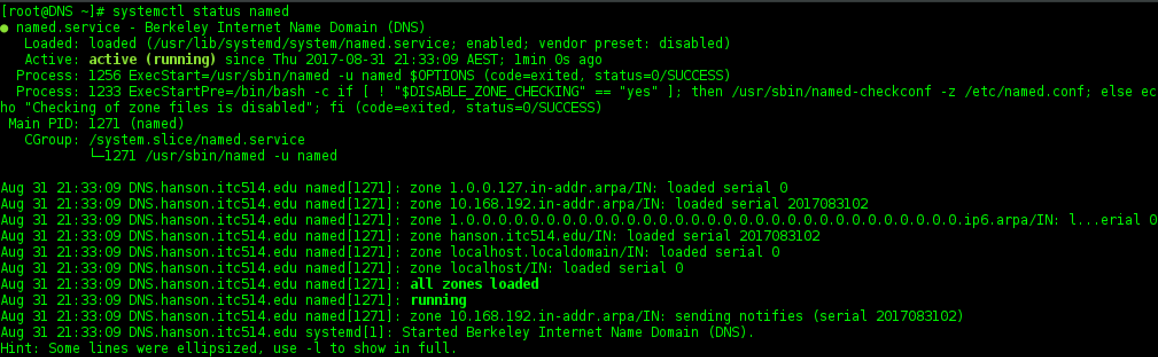

## DNS Testing

Now that I have my zone files loading properly and the named service starting without error, it is time to move on and test that named is resolving address resolution requests. The first test I tried was to ping “host1”, which game me “Name or service not known” which is the same error that was produced when pinging google.com. This means that the ping command was not able to see the host1 entry in my zone file. I then tried to use the “nslookup” command on the server IP address, to no avail.

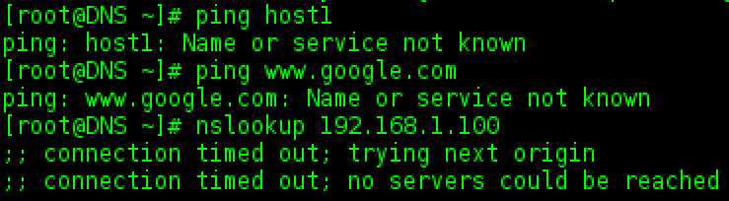

I checked that my zone files and named.conf file were still configured correctly and everything looked fine. I then checked my interface configuration and realised that I hadn’t entered a DNS server in the configuration. I added “127.0.0.1” as the DNS server and rebooted the server.

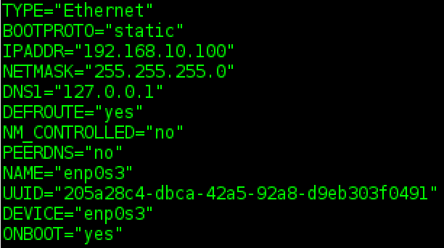

Even after this configuration modification, none of my DNS requests are working properly. After doing some further digging in configuration files and settings of the server, I found that the date and time was incorrect. I set the data and time correctly and now my requests are working as they should, at least locally anyway.

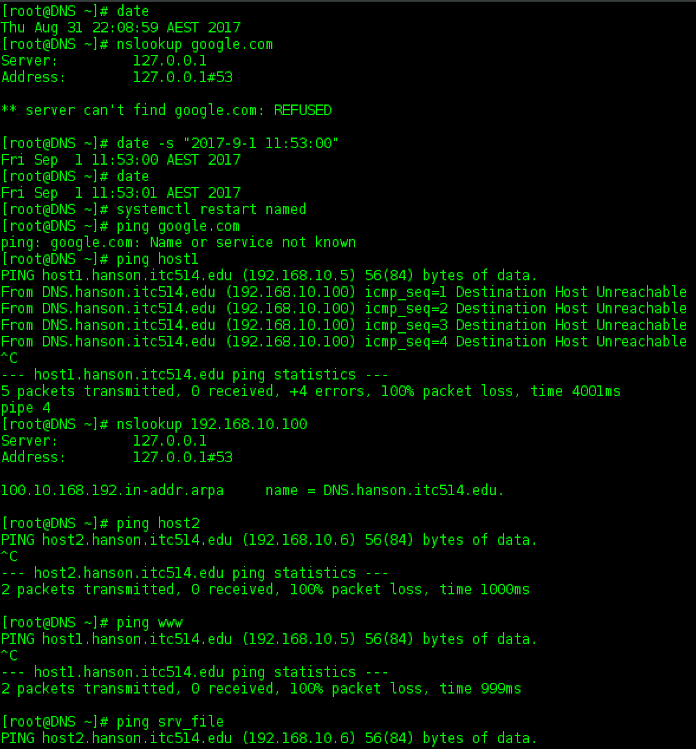

The next step is to test DNS from an external client. As recommended by Phil in the discussion forum, I configured the network adapter for the VM in Bridged Mode and made sure that Cable Connected was checked.

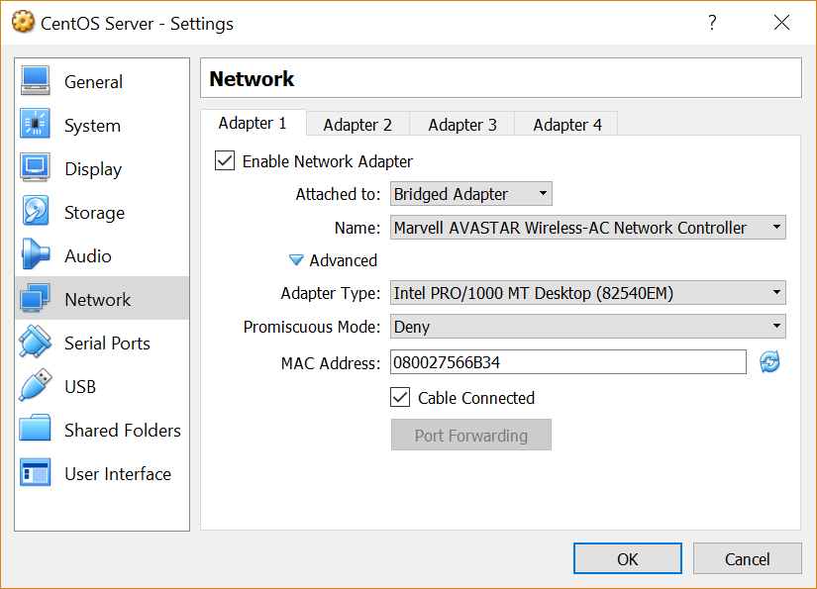

I then booted the machine to check that the network adapter was able to receive an IP address that is in the host’s subnet, which it was.

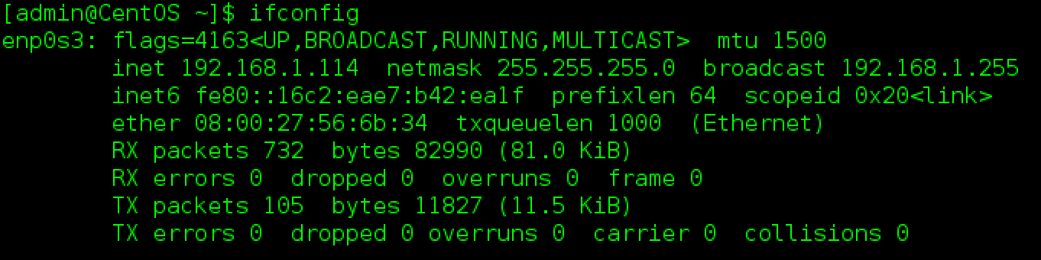

Testing internet connectivity.

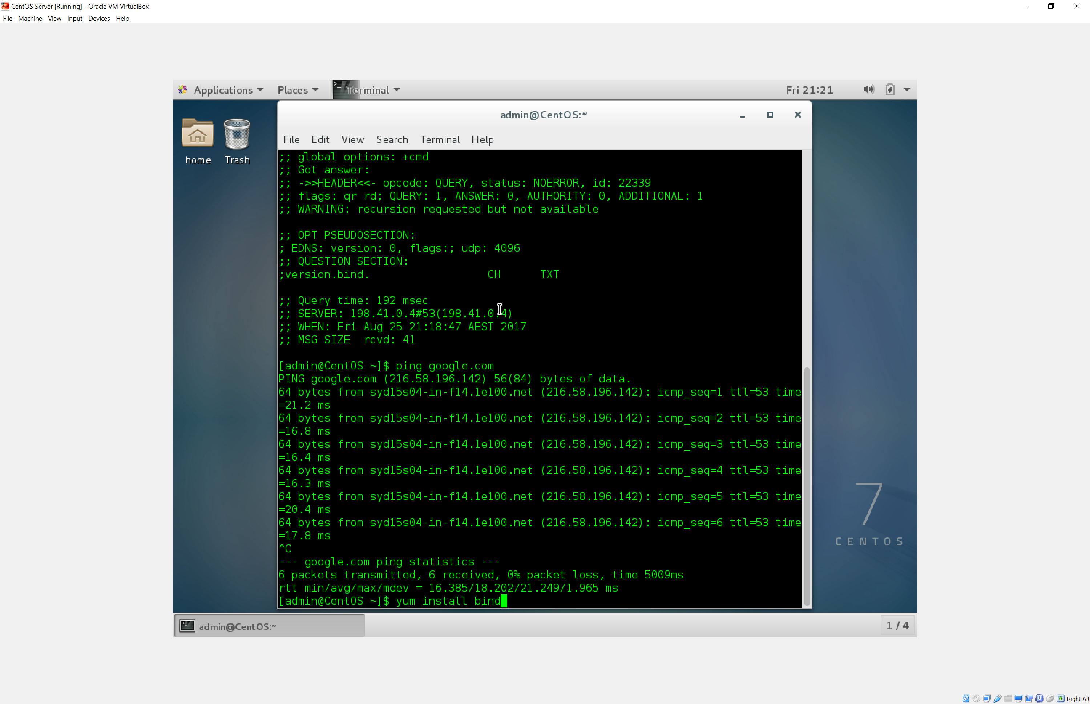

I then made sure that my host was set so that the DNS server was 192.168.10.100 and that the IP address was in the same subnet.

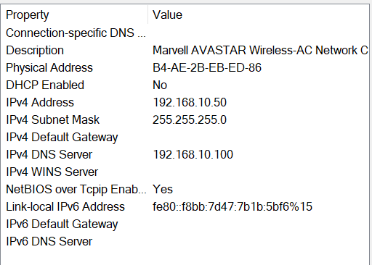

I was able to ping 192.168.10.100, so the network connectivity was working fine.

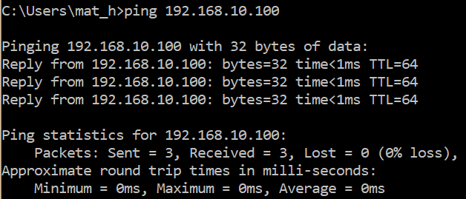

But I am unable to ping hostnames of devices with A and PTR records.

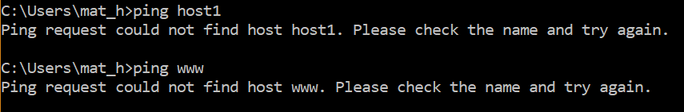

I found that the DNS server was running a firewall which was stopping some information, as I am now able to receive the hostname of the server when using “ping -a”. I am still however unable to ping other hostnames.

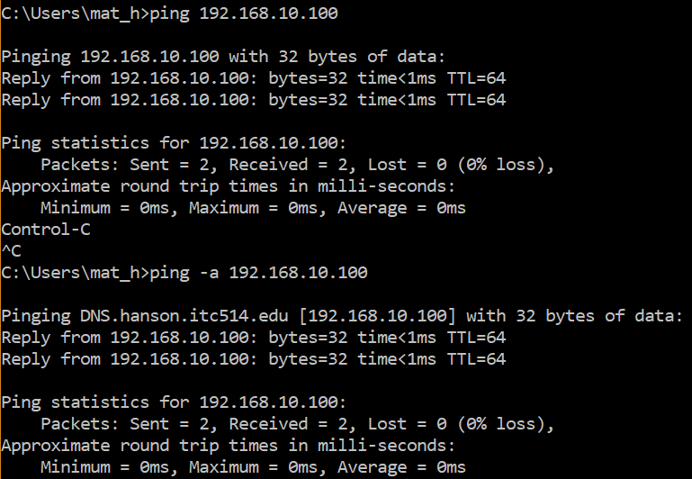

I tested with nslookup and it is now working fine and giving me reverse lookup information.

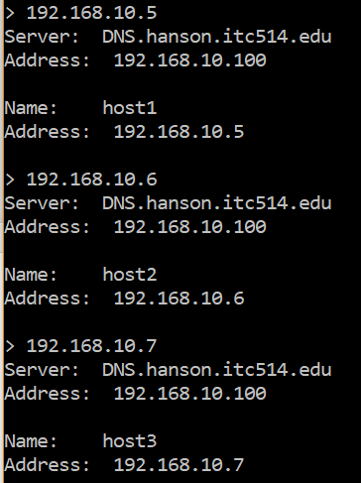

After trying a multitude of fixes, I was still unable to get my Windows host to ping a hostname which had been setup on the DNS server. I am not sure why this isn’t working as both forward and reverse lookup works fine on the DNS server itself. Only reverse lookup seems to be working externally.

# Part Two

## Create New User

The first task is to create a new user named “assgn2”. Using the “useradd” and “passwd” commands I will create a new user and set the password for the account (Red Hat, Inc, 2006).

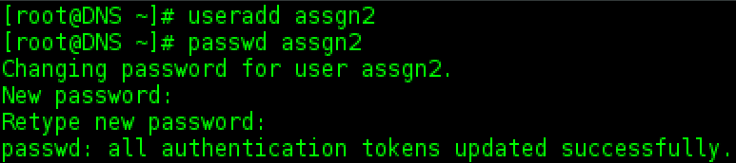

## Create Files in Home Directory

I checked the /home/ directory to make sure that the new user’s home directory had been created as that is where the new files will be created.

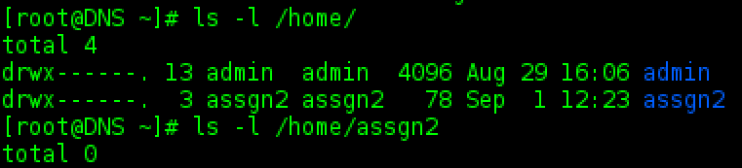

To create the processes.txt file and populate it with a detailed listing of all processes currently running on the system, I decided to pipe “ps -aux” to the file. I then chained this command with “chmod 0666” to set the permissions as required. I then checked the permissions on the file and ran a “cat” command to make sure that the file had been populated with the required data.

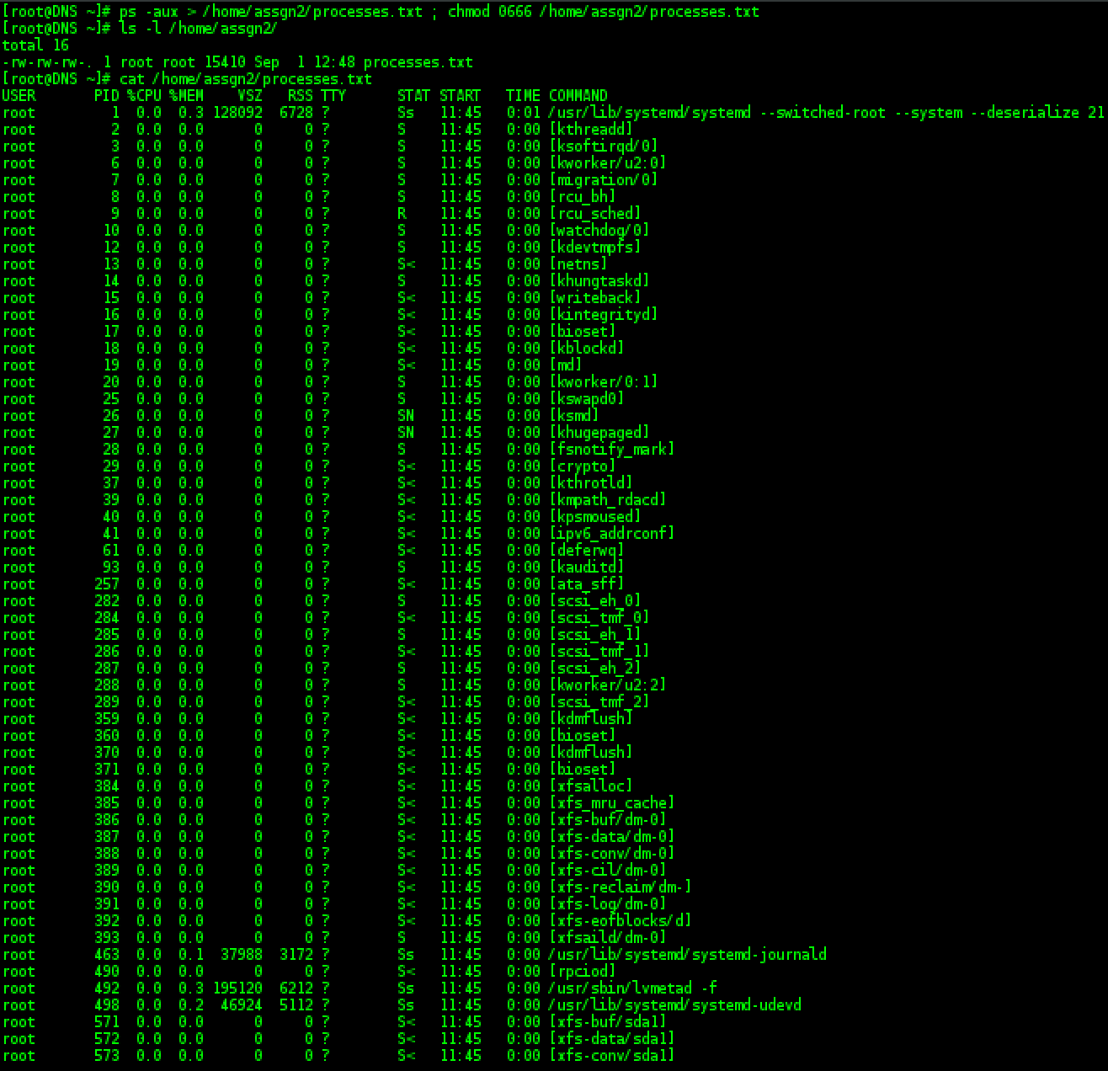

Next, I will create the hidden file “.test_config”. I used an echo command and piped to the file name to create it. I then used a chain command to change the permissions so that only the root user (who is the owner) has any permissions - which are read, write and execute. I then tested to make sure that the file was created, the permissions were set correctly, and the contents of the file were correct.

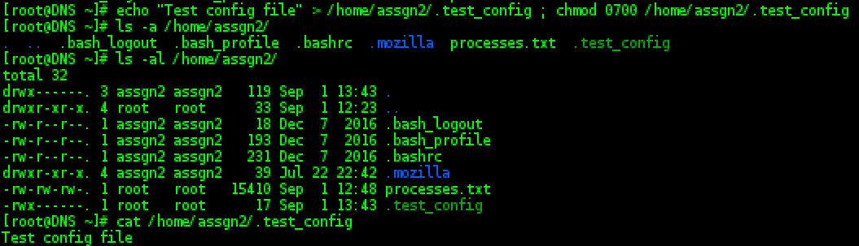

For the symbolic link file, I decided to use /var/log/yum.log. I used the “ln -s” command to create a symbolic link file called /home/assgn2/yumsl. I then checked to make sure that the file was created and linked to the correct file using “ls -l” command.

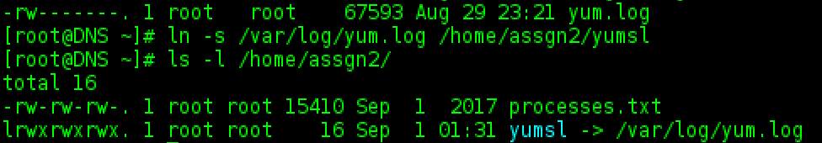

I used the “mkdir -m” command to create the test_dir directory and set the permissions on creation. I then used “ls -l” to make sure the folder had been created with the correct permissions, which it had.

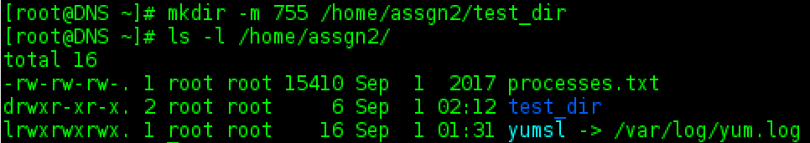

Lastly, I will create “script1” which will remove the other executable permission from all files in a folder. At first I was going to write an IF ELSE statement but then found a more elegant solution using shell parameter expansion (GNU.org, 2016).

Firstly, I just wanted to test that the code was going to work the way that I understood it to work, so I tested by printing the variable to terminal. In this state however, without an argument it would just print “pwd” rather than the current directory. I tried a couple of different things, but still couldn’t get it to work.

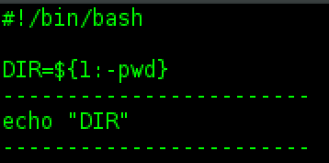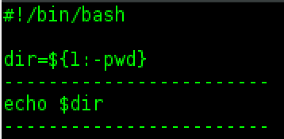

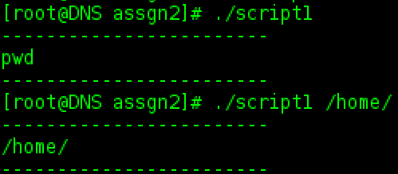

Before going any further, I decided to take a quick break and set the permissions on the script file.

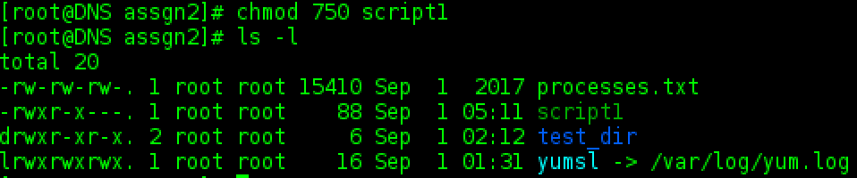

I then tried with “./” to no avail.

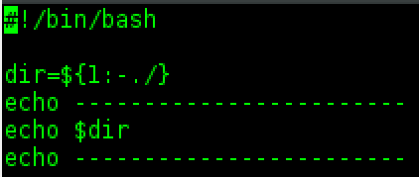

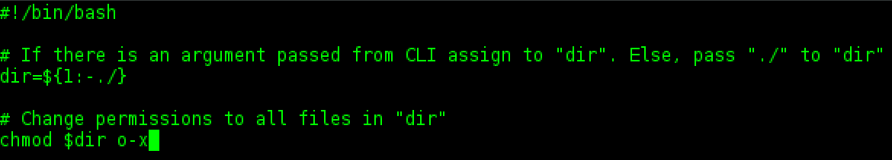

After searching for some time, I finally found how to refer to the current working directory, by using $(pwd) (Govind Kailas, 2015).

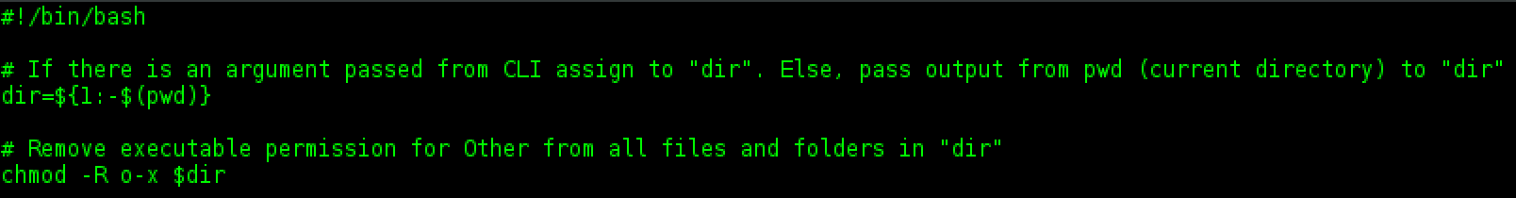

I then tested the script without an argument.

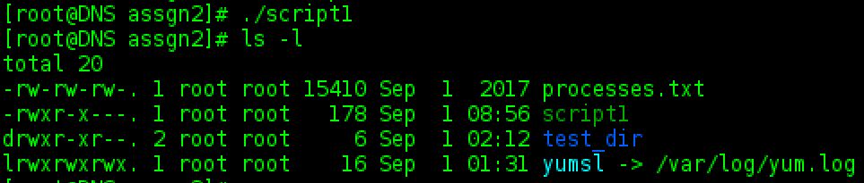

To test the script even further, I reenabled other executable permission on two files within /home/assgn2 and then reran the script. This removed the “other execution” bit from both files.

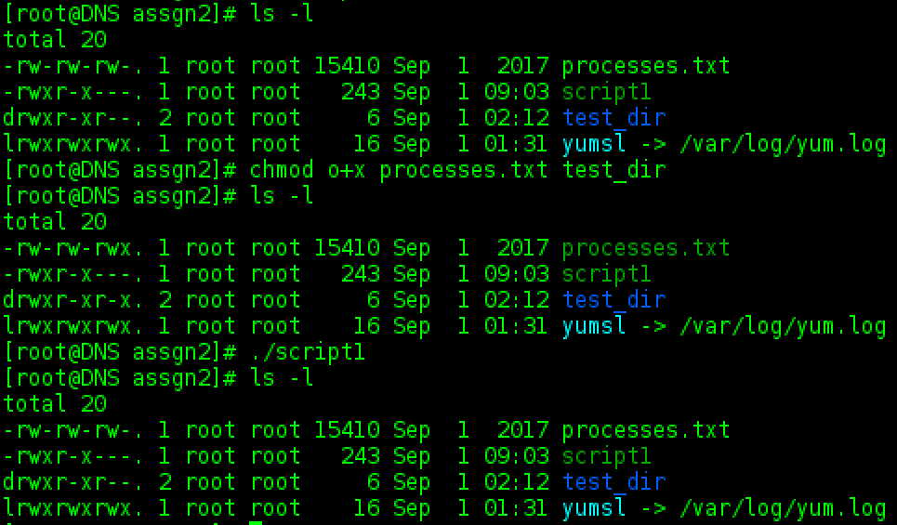

To test that the command line argument was working, I copied two files from /home/assgn2 to /home/ and then ran the script from /home/assgn2 while using /home/ as the command line argument. The script works as required.

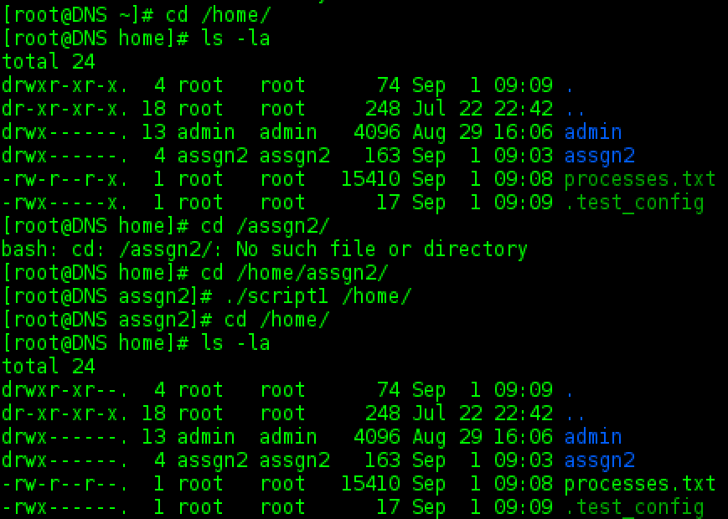

## References

CentOS.org. (2005). Managing software with yum. Retrieved from <https://www.centos.org/docs/5/html/yum/sn-managing-packages.html#sn-yum-installing-withrepositories>

Geniar, M. (2015). CentOS 7 NetworkManager Keeps Overwriting /etc/resolv.conf. Retrieved from <https://ma.ttias.be/centos-7-networkmanager-keeps-overwriting-etcresolv-conf/>

GNU.org. (2016). Bash Reference Manual. Retrieved from <http://www.gnu.org/software/bash/manual/bashref.html#Shell-Parameter-Expansion>

Govind Kailas. (2015, March 4). How can I get the current working directory [Blog Comment]. Retrieved from <https://unix.stackexchange.com/questions/188182/how-can-i-get-the-current-working-directory>

Red Hat, Inc. (2006). Red Hat Enterprise Linux Deployment Guide. Retrieved from <https://www.centos.org/docs/5/html/5.1/Deployment_Guide/s2-users-add.html>

Raj. (2017). Change HostName In CentOS 7 / RHEL 7. Retrieved from <http://www.itzgeek.com/how-tos/linux/centos-how-tos/change-hostname-in-centos-7-rhel-7.html>